E/16/388

CO322 Data Structures and Algorithms - Graph ADT

Answers

1. Find out what is the Transitive Closure of a graph.

Given a directed graph G, in transtitive closure G*, from node v to node w there is an edge if and only if there is a directed path from v to w in G.

2. Manually compute the Transitive Closure for the following graph:

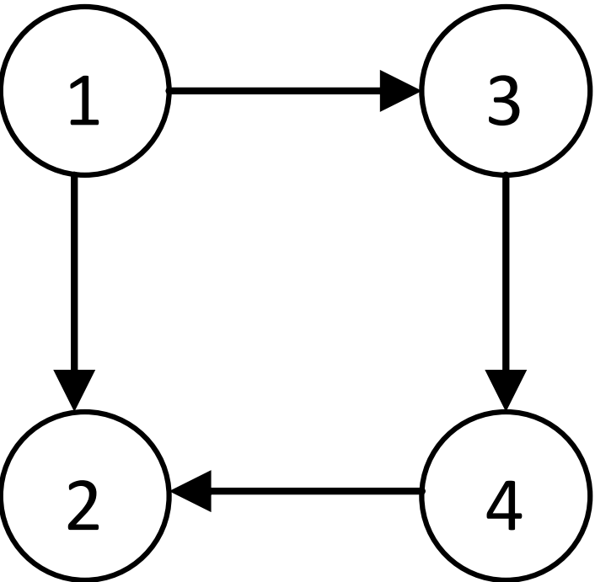

Adjacency matrix of graph

|  |  |  |  |
| --- | --- | --- | --- |
| 0 | 1 | 1 | 0 |
| 0 | 0 | 0 | 0 |
| 0 | 0 | 0 | 1 |
| 0 | 1 | 0 | 0 |

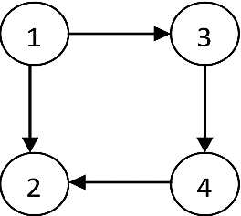

Adjacency matrix of graph using 1 or/and 2 nodes as intermediary nodes

|  |  |  |  |
| --- | --- | --- | --- |
| 0 | 1 | 1 | 0 |
| 0 | 0 | 0 | 0 |
| 0 | 0 | 0 | 1 |
| 0 | 1 | 0 | 0 |



Adjacency matrix of graph using 1 , 2 and/or 3 nodes as intermediary nodes

|  |  |  |  |
| --- | --- | --- | --- |
| 0 | 1 | 1 | 1 |
| 0 | 0 | 0 | 0 |
| 0 | 0 | 0 | 1 |
| 0 | 1 | 0 | 0 |



Adjacency matrix of graph using 1 , 2, 3 and/or 4 nodes as intermediary nodes

|  |  |  |  |
| --- | --- | --- | --- |
| 0 | 1 | 1 | 1 |
| 0 | 0 | 0 | 0 |
| 0 | 1 | 0 | 1 |
| 0 | 1 | 0 | 0 |

This is the transtitive closure of given graph.

3. Based on the Graph Traversal algorithm discussed in the class, write a C program to compute and print the Transitive Closure of a given graph. Use the following graph to test your program:

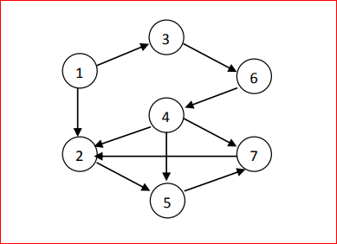

This was implemented in lab5.c file

